**NetSim Installation Guide**

**Win 7 (SP1 or higher), Win 8 and Win 10**

**32/64 Bit English Version**

The information contained in this document represents the current view of TETCOS on the issues discussed as of the date of publication. Because TETCOS must respond to changing market conditions, it should not be interpreted to be a commitment on the part of TETCOS, and TETCOS cannot guarantee the accuracy of any information presented after the date of publication.

This manual is for informational purposes only. TETCOS MAKES NO WARRANTIES, EXPRESS, IMPLIED OR STATUTORY, AS TO THE INFORMATION IN THIS DOCUMENT.

**Warning! DO NOT COPY**

Copyright in the whole and every part of this manual belongs to **TETCOS** and may not be used, sold, transferred, copied or reproduced in whole or in part in any manner or in any media to any person, without the prior written consent of **TETCOS**. If you use this manual you do so at your own risk and on the understanding that **TETCOS** shall not be liable for any loss or damage of any kind.

TETCOS may have patents, patent applications, trademarks, copyrights, or other intellectual property rights covering subject matter in this document. Except as expressly provided in any written license agreement from TETCOS, the furnishing of this document does not give you any license to these patents, trademarks, copyrights, or other intellectual property. Unless otherwise noted, the example companies, organizations, products, domain names, e-mail addresses, logos, people, places, and events depicted herein are fictitious, and no association with any real company, organization, product, domain name, email address, logo, person, place, or event is intended or should be inferred.

Rev 11.1 (V), Mar 2019, TETCOS. All rights reserved

**All trademarks are property of their respective owner.**

**Contact us at**

TETCOS

214, 39th A Cross, 7th Main, 5th Block Jayanagar,

Bangalore - 560 041, Karnataka, INDIA. Phone: +91 80 26630624

E-Mail: [sales@tetcos.com](mailto:sales@tetcos.com)

Visit: [www.tetcos.com](http://www.tetcos.com)

Contents

1 System Requirements 4

2 CD ROM / FTP Delivery 5

3 NetSim Installation 7

3.1 Silent installation 19

4 NetSim RLM Dongle Installation 21

4.1 Installation 21

4.2 Running RLM Dongle (Server) 24

4.3 Running NetSim Software 25

4.4 To View the License usage: 27

5 Re-Installation 30

6 Un-Installation 32

7 Troubleshooting 37

7.1 Adding exception for NetSim in Kaspersky Antivirus 37

7.2 Adding exception for NetSim in Trend Micro Antivirus? 44

# System Requirements

1. **NetSim Client (installs locally):**

* Hardware – Processor: i3 equivalent or above, 2GB RAM (minimum), Monitor resolution (1024*768 min, with 100% scaling)
* Operating system – Win 7 (SP1 or higher), Win 8 or Win 10
* Software - MS Office, Adobe Reader
* Development Tool - Visual Studio -- Community Edition or Higher
  + NetSimv8 / v8.1 / v8.3 / v9 / v9.1 -- Microsoft Visual Studio 2010 is required for writing and debugging custom code
  + NetSim v10 / v11 -- Microsoft Visual Studio 2015 (or Higher) is required for writing and debugging custom code

1. **License Server (for running Host ID/Dongle locked floating licenses, not applicable for node locked licenses):**

* Any one system will have to be made as the license server, and it is to this PC that the dongle will be connected. The dongle is a USB device which controls the licensing.
* Any PC can act as a server and the system (hardware / OS) requirements is same as that applicable for NetSim clients. USB Port is required for connecting and running the dongle.
* Client systems should be able to communicate with license server through the network.

# CD ROM / FTP Delivery

Each CD or FTP delivery of NetSim version will contain

1. **NetSim_Software**

This folder contains the setup files needed to install the NetSim software.

1. **Driver_Software**

This folder contains the setup file for driver software needed to run the Reprise License Manager (RLM) dongle.

1. **NetSim_License_Server**

This folder contains the license files, rlm.exe and tetcos.exe for running the RLM dongle.

1. **Source_Code**

This folder contains

* Protocol source code in NetSim Std and Pro
* “C” source codes for the programming exercise menu for NetSim Acad)

1. **User_Manual**

This folder contains Experiment Manual and User Manual.

1. **Installation_Guide**

A step by step document guiding the user on how to install and run NetSim

**CD / DVD**

* Insert the disc in the drive.
* Double click on My Computer and access the CD Drive
* Double click on NetSim_Software folder.
* Double click on NetSim_Standard_12_0.exe (or NetSim_Pro_12_0.exe, or NetSim_Academic_12_0.exe, based on the version shipped to you)
* Installation of the **NetSim** begins as explained in the next chapter

Each prompt displayed during the process provides you with some background information and prompts you to either **Continue** or **Exit.**

**FTP Delivery**

* Uninstall any previously installed versions of NetSim and all associated third party tools.
* Click and Download NetSim License Server first. This zip file must be downloaded/copied on the PC which you would be using as the license server, and then unzipped.
* Download and install NetSim_Standard_12_0.exe (or NetSim_Pro_12_0.exe, or NetSim_Academic_12_0.exe, based on the version shipped to you). Please ensure that all third party software’s are installed. The installation procedure is explained below.

# NetSim Installation

Double click on the setup file.

Click on **Yes** button the a User Account control message “Do you want to allow the following program from an unknown publisher to make changes to your computer”

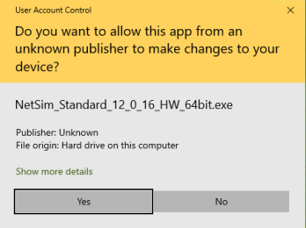

NetSim Software installation begins with a **Welcome Screen**.

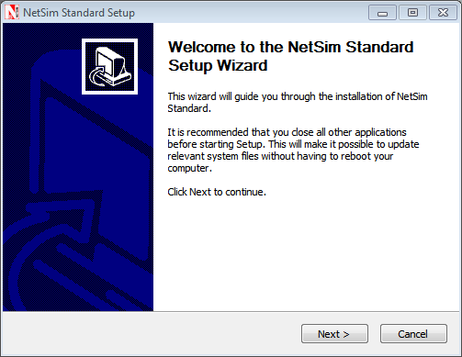

Click on the **Next** button. In the next screen, the License agreement will be displayed.

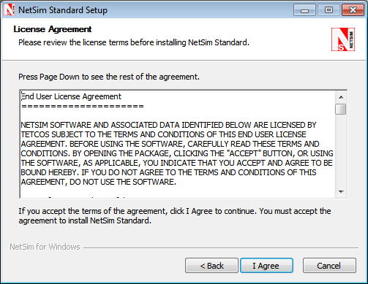

Read the agreement carefully, scroll down to read the complete license agreement. If the requirement of the license agreement is accepted click “**I** **Agree**” button else quit the setup by clicking **Cancel** button.

If you agree with the license agreement, you will be prompted to select the components to be installed. The list of components is available for selection and assembly only in the Standard and Pro version. NetSim Academic is available as a single package.

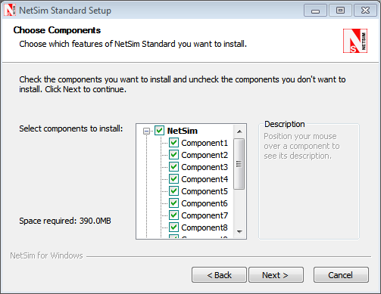

Click on the **Next** button.

**Note:** Select all the supporting applications for complete installation of the software.

In the next screen, you will be requested to enter the installation path. Select the path in which the software needs to be installed and click on **Next** button.

**Note:** In the case you are installing 32bit NetSim in a 64 bit machine, ensure that the path is <OS installed drive>C:/Program Files(x86)/NetSim Standard

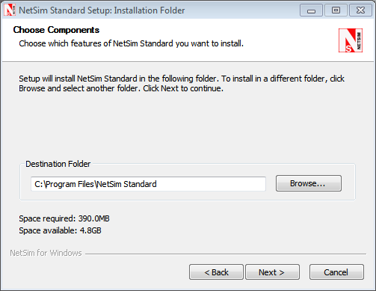

On the next screen, you will be requested to enter the Start menu folder name.

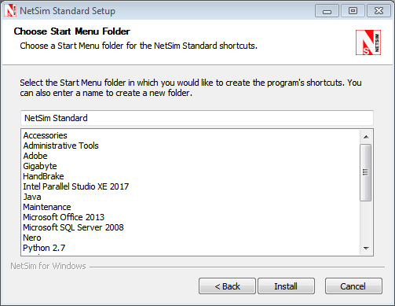

Click on the **Install** button to start the installation. The installation process begins.

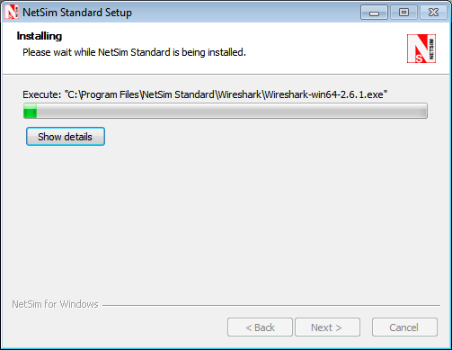

After the installation of required files, the installation of supporting software begins. For **NetSim Academic**, Adobe Flash Player, winPcap, wireshark will be installed. For **NetSim Standard Version** and **Pro Version** along with Wireshark winPcap installation is done and Python installation will start by default (if not deselected during 3rd party software selection)

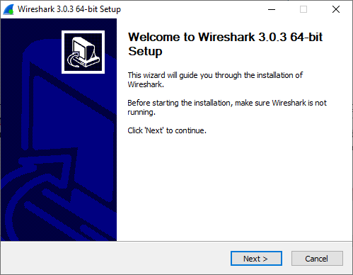

Click on **Next** to start **Wireshark** installation. In the following window, click on **I Agree.**

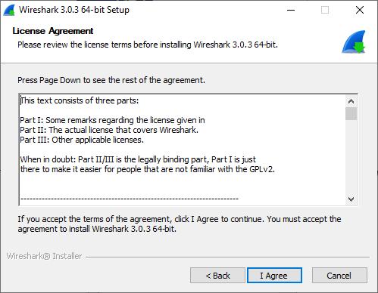

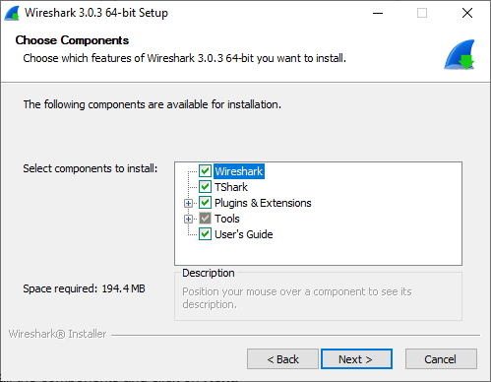

Select all the components and click on **Next.**

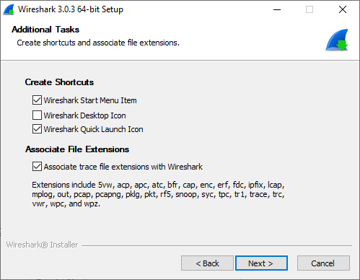

Click on **Next** to go to **Install Location** window as shown below. Specify the destination and select **Next.**

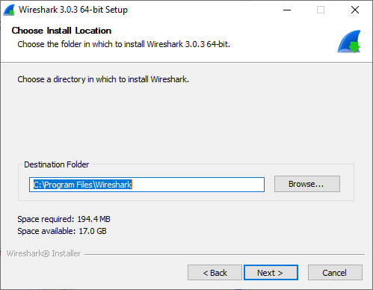

To **Install Npcap,** click on **Next.**

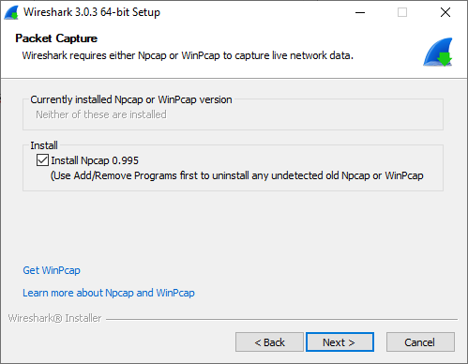

To Install **Npcap**, click on **Install**.

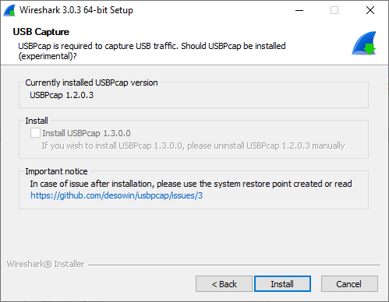

For installation of Npcap, click on **I Agree.**

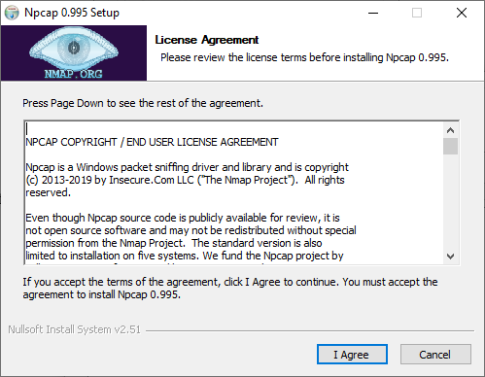

In the following window, click on

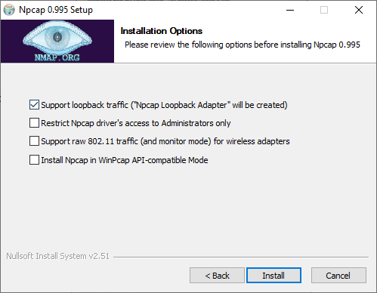

Click on Next.

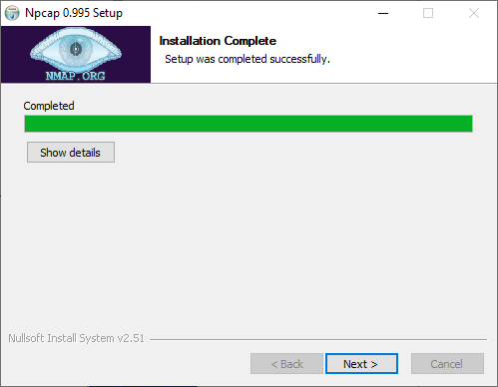

Click on finish to close wizard.

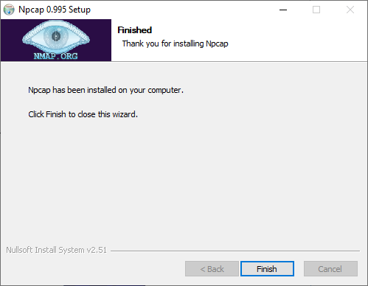

Once installation is completed, click on Next.

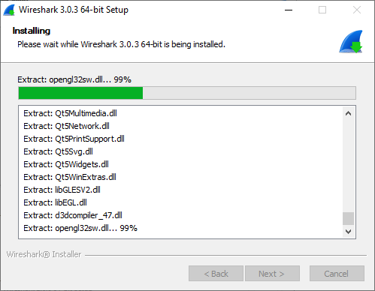

Click on Finish to complete WireShark installation.

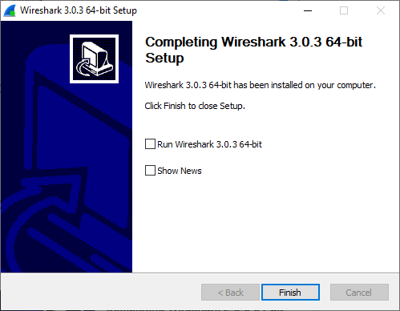

Select **I agree** and click on **Install** to continue installation of Microsoft Visual C++ 2015.

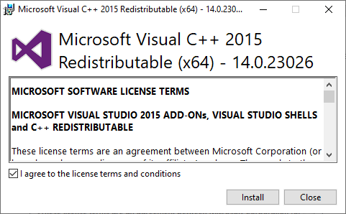

Once installation is completed, Click on **close**.

It executes necessary files to be installed.

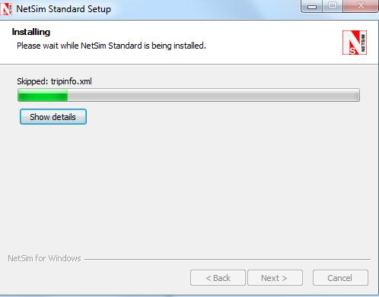

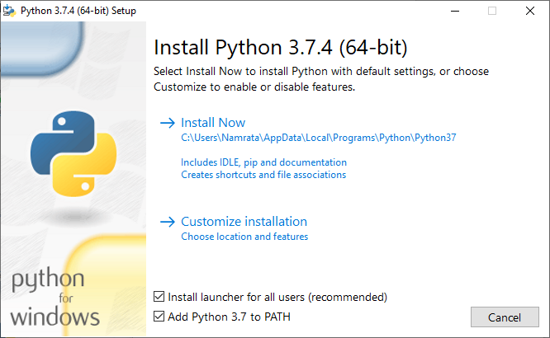

To start Python software installation, select the checkbox of "Add python 3.7 to PATH", then select Install Now and the Installation begins.

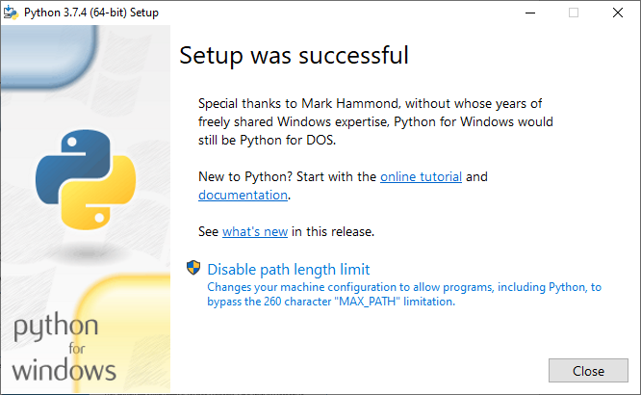

Click on **Close** once setup was successful**.**

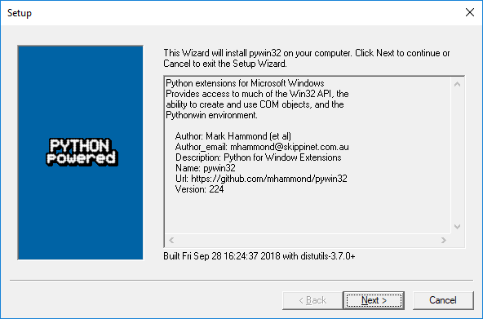

To install Pywin32, Click on **Next**

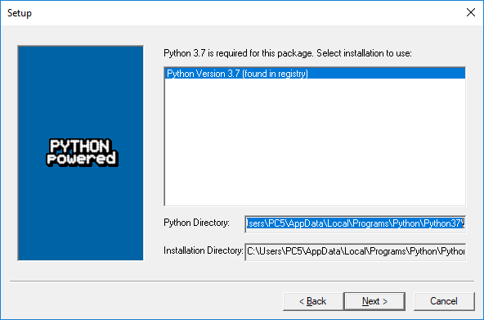

The Setup is ready to install. Click on **Next** button.

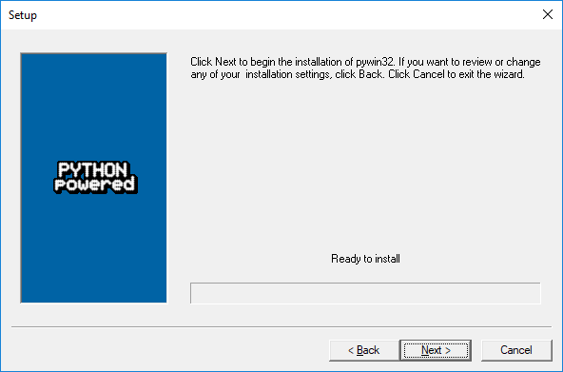

Click on **Next** button and Pywin32 installation begins.

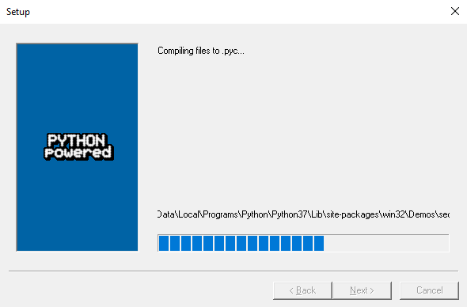

Once it is complete, click on **Finish** button.

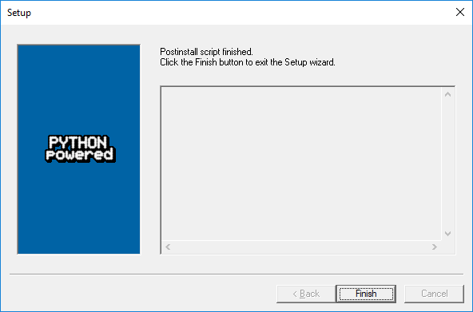

This completes the Installation of python software. NetSim complete Setup wizard appears as shown below. Select **Run NetSim Standard** and click on **Finish** button to complete the installation process of NetSim.

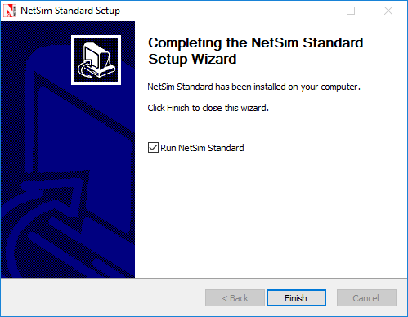

Select “**Run NetSim**” and then click on the **Finish** button.

This completes the installation of NetSim Software.

**Note**: During the installation of NetSim Academic version the supporting software installed are Adobe Flash player and WinPcap.

## Silent installation

Steps for silent installation in NetSim are as follows:-

1. For example, let us take the NetSim Standard 64 bit setup. Right click on NetSim Standard 64bit setup 🡪 go to properties and copy the location.

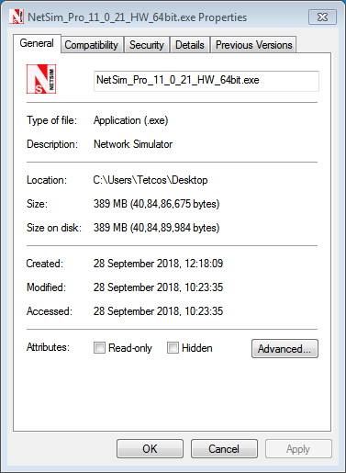

1. Open command prompt and paste the copied location as shown below:🡪cd <setup location>

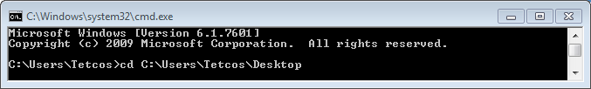

Then, press enter.

1. Run Execute Command with the following parameters,

**NetSim_Standard_12_0_16_HW_32bit.exe /S /silent=1**

*><setup><space>/S<space>/silent=1*

1. /silent=1 : will install all NetSim supported softwares silently
2. /S : will Install NetSim itself Silently

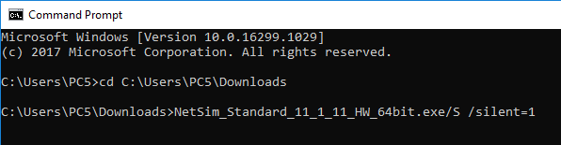

Then press enter.

4. Users can click on “Yes” as shown below to begin installation of NetSim Standard.

NOTE: Complete installation of NetSim may take upto 2 to 3 minutes.

# NetSim RLM Dongle Installation

This section guides you to install the **RLM** **Dongle** software from the CD-ROM.

## Installation

* Insert the CD-ROM disc in the CD drive.
* Double click on My Computer and access the CD Drive
* Double click on **Driver_Software** folder.
* Open 32bit_Installer folder or 64bit_Installer folder depending on the system architecture.
* Double click on **HASPUserSetup.exe**

Each prompt displayed during the process tells you what it is about to do and prompts to either **continue** or **Exit**.

Setup prepares the installation wizard and the software installation begins with a **Welcome Screen**.

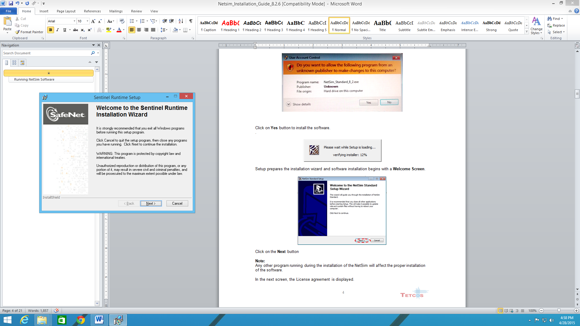

Click on the **Next** button

***Note: Any other program running during the installation of the Dongle will affect the proper installation of the software.***

In the next screen, the License agreement is displayed.

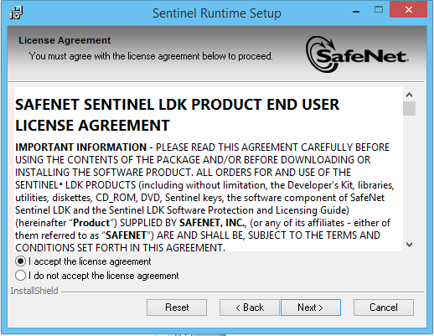

Read the license agreement carefully, scroll down to read the complete license agreement. If the requirement of the license agreement is accepted select the “**I** **accept**” button else quit the setup by clicking **Cancel** button.

Click on the **Next** button

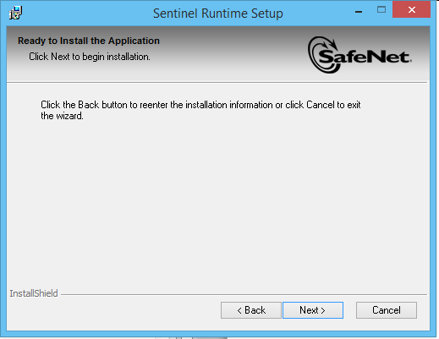

Click on the **Next** button. The installation process begins**.**

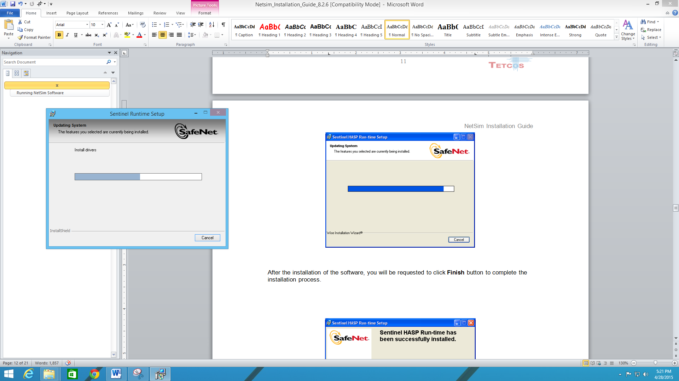

After the installation of the software, you will be requested to click **Finish** button to complete the installation process.

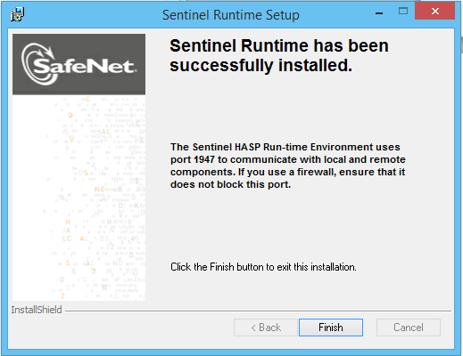

Now the **RLM driver software** is installed successfully.

If the driver has been successfully installed then upon connecting the Dongle in the USB port red light would glow (Refer picture below). If the driver is not correctly installed this light will not glow when the dongle is connected to the USB port.

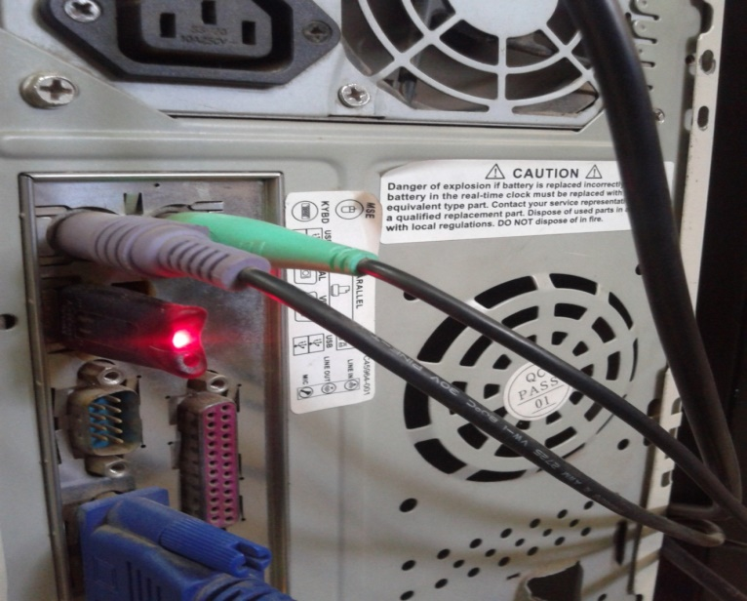

## Running RLM Dongle (Server)

After the Driver Software installation, connect the **RLM dongle** to the **system USB port**.

* Double click on My Computer and access the CD Drive
* Copy the **NetSim License Server** folder and paste it on **Desktop**.
* Double click on **NetSim License Server** folder from Desktop.
* Double click on **rlm.exe**

**Note**: For running **NetSim**, **rlm.exe** must be running in the server (license server) system and the server system IP address must be entered correctly. Without running **rlm.exe**, **NetSim** won’t run.

When you run rlm.exe, the screen will appear as shown below.

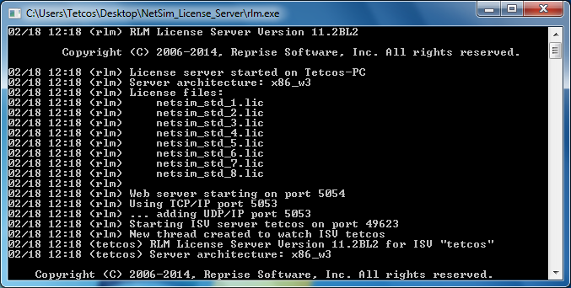

## Running NetSim Software

After running **rlm.exe**, click the NetSim icon in the Desktop. The screen given below will be obtained.

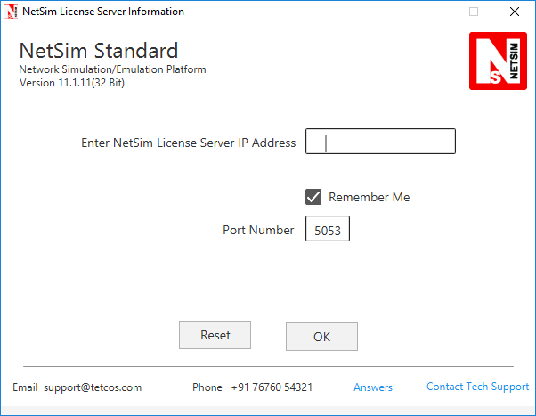

Enter the **Server IP address** where the **rlm.exe** is running, then click ok button.

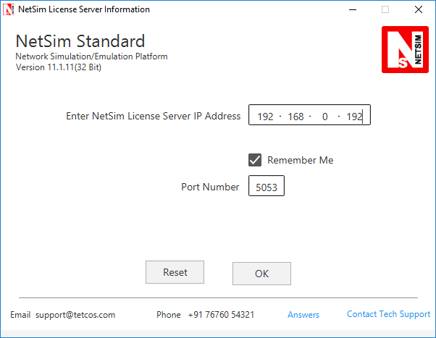

And then you would reach the main screen of NetSim

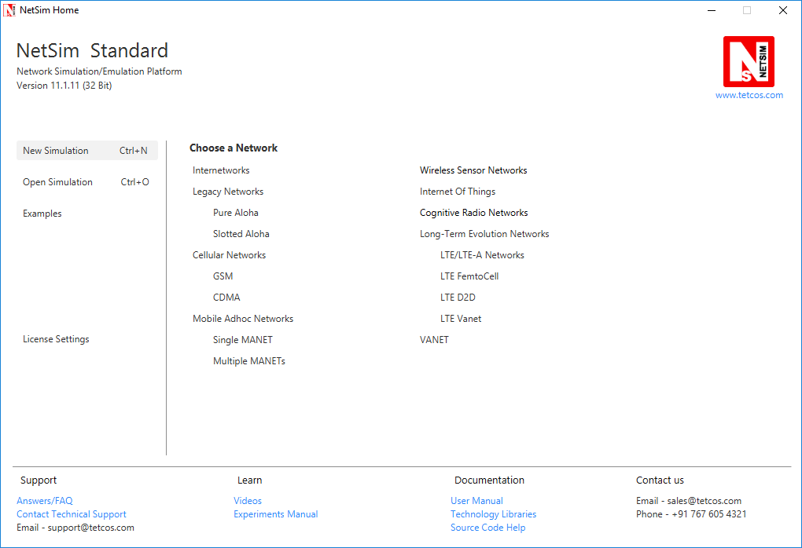

## To View the License usage:

If RLM dongle is running on the same machine, then open web browser and type, **localhost: 5054,** where 5054 is the port number through which the server communicates with the client.

If RLM dongle is running on different machine, then type, ip address of that machine followed by: 5054. E.g.: 192.168.0.10:5054.

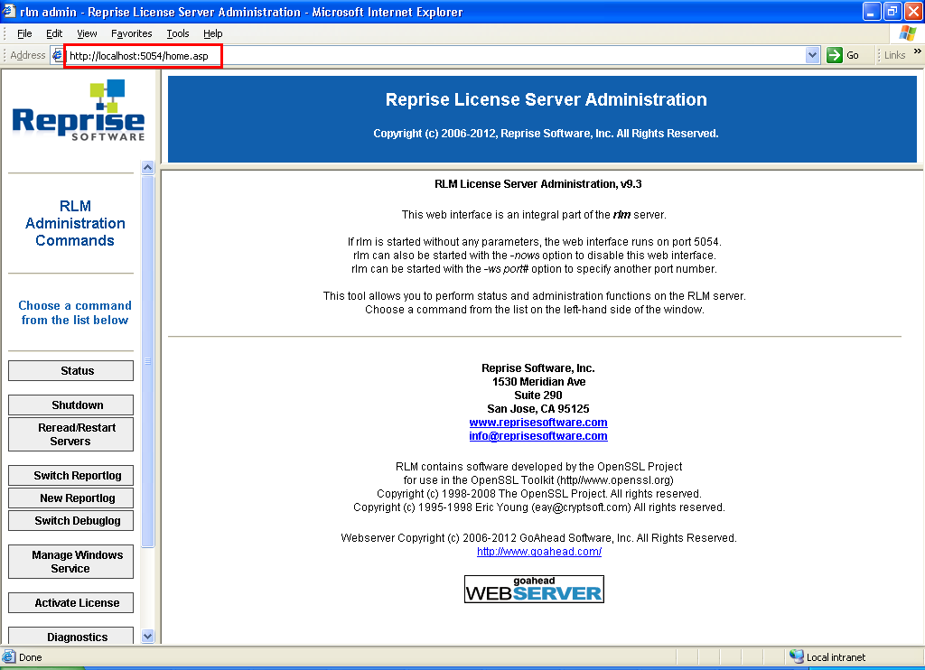

Note: If you open NetSim License Server through Internet Explorer, then type http://localhost: 5054 (if RLM dongle is running on the same machine) and http://<IP Address of the server>:5054(if RLM dongle is running on different machine). Eg: http://192.168.0.10:5054.

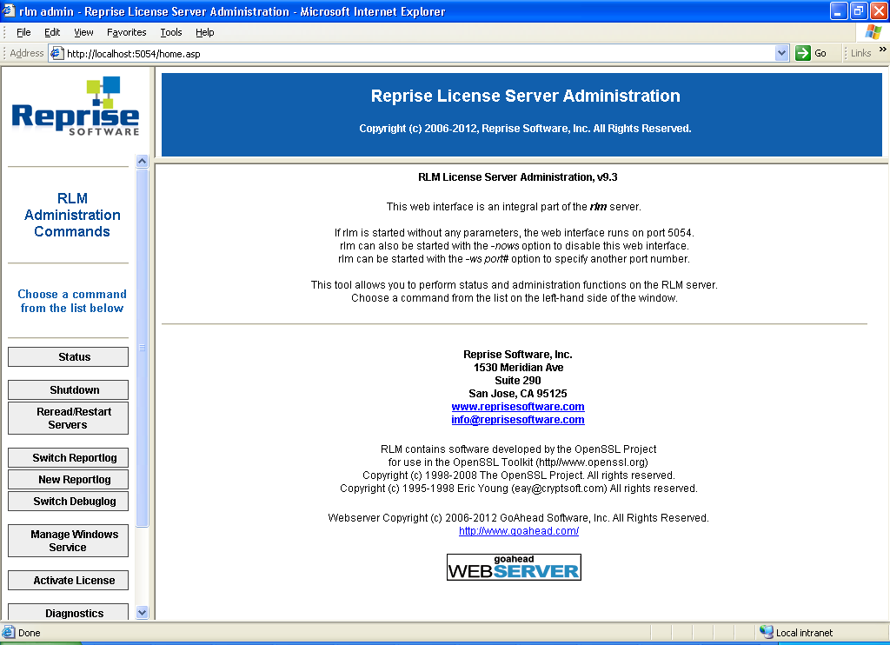

If you click **Status** from the menu on the left, the main status screen is displayed in the view area as shown below.

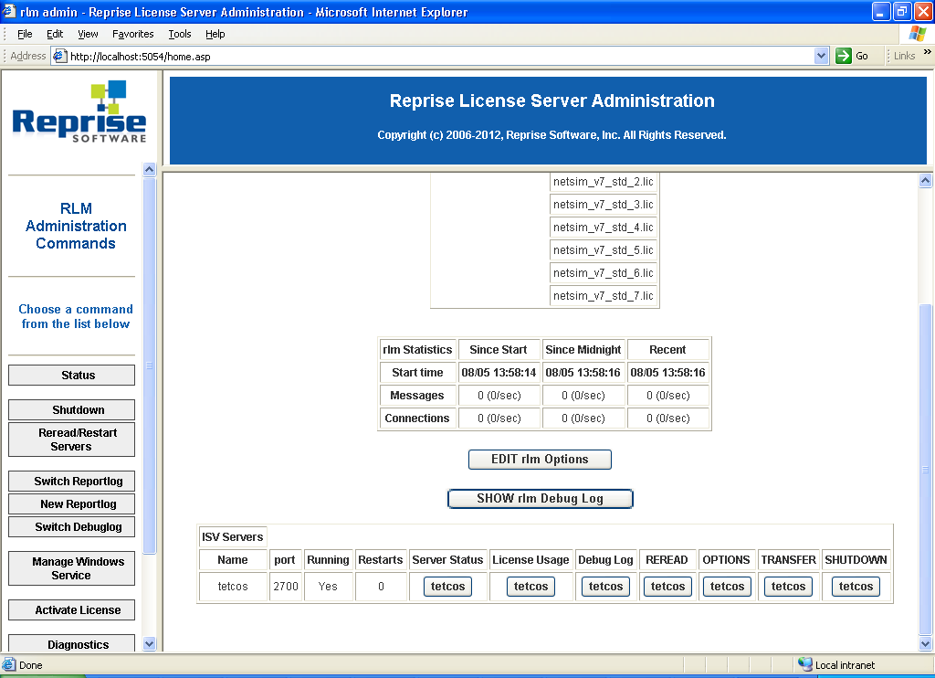

If you click on Tetcos under License Usage, you will get the following screen.

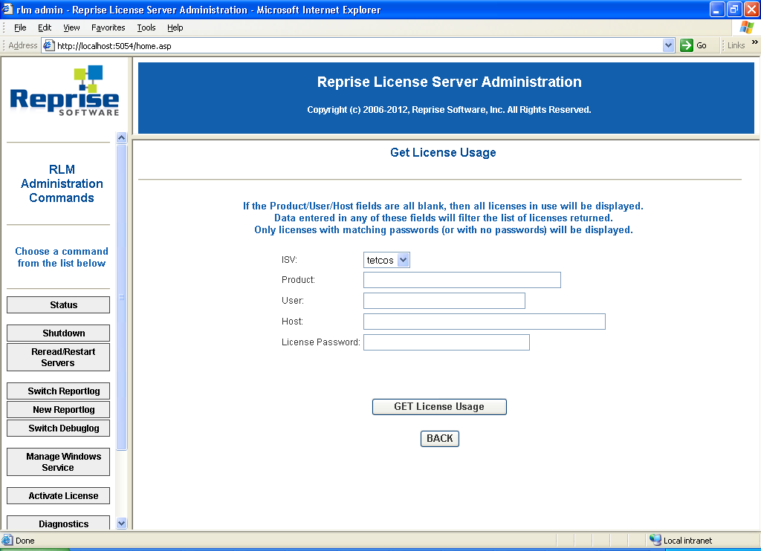

If you click on **GET License Usage** button, the License status will be shown as given below.

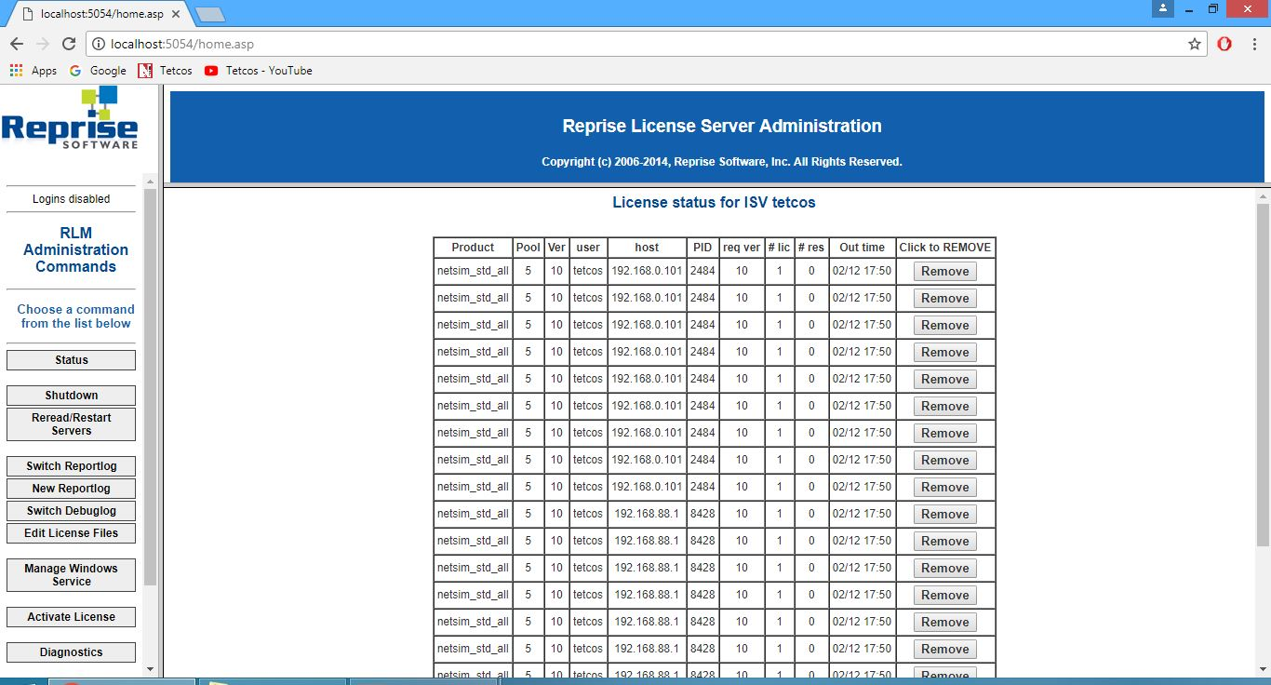

# Re-Installation

When **NetSim (older version)** is already installed, if we try to install **NetSim** for the second time, the following message box will be appeared.

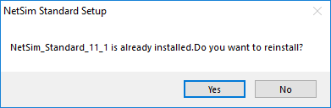

Click **Yes to** re-install **NetSim** or click Noto quit. If you click **Yes** then following window will appear.

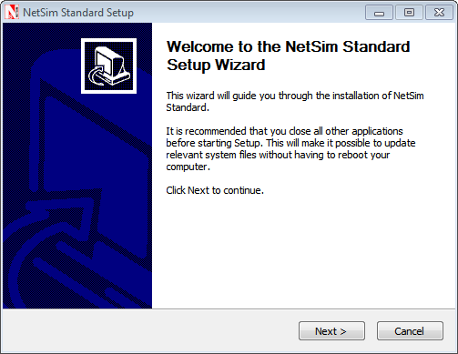

Click on the **Next** button

***Note:***

***Any other program running during the installation of the NetSim will affect the proper installation of the software.***

In the next screen, the License agreement is displayed.

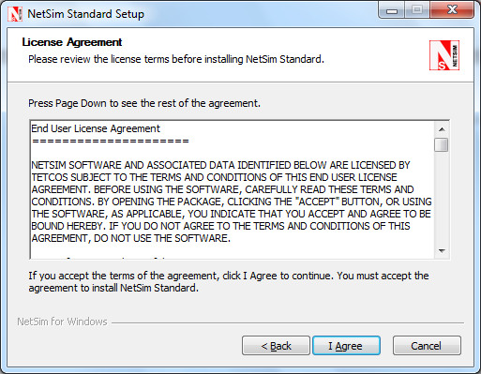

Read the agreement carefully, scroll down to read the complete license agreement. If the requirement of the license agreement is accepted click “**I** **Agree**” button else quit the setup by clicking **Cancel** button.

If you agree with the license agreement, you will be prompted to select the components to be installed. Click on the **Next** button. If it is NetSim Standard Version you will get the following screen

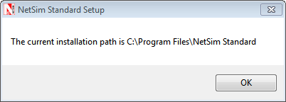

Click on OK button and follow the same procedure followed in Installation process

# Un-Installation

Click Start Menu and select control panel 🡪 **NetSim Standard or NetSim Pro or NetSim Academic 🡪 Uninstall option.**

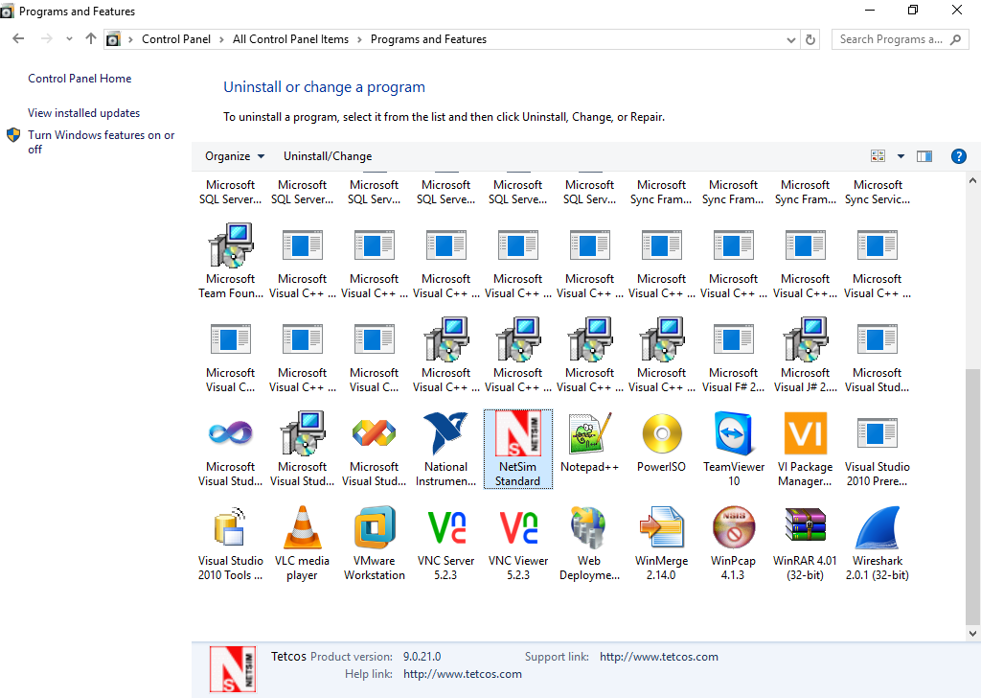

This shows a popup menu as shown below.

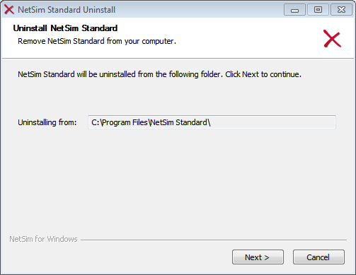

Click the **Next** button.

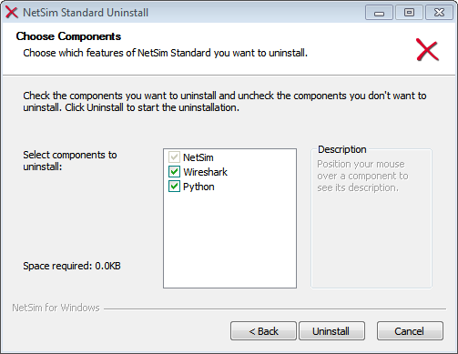

Select the software to be uninstalled and Click on the **Uninstall** button.

The un-installation process begins.

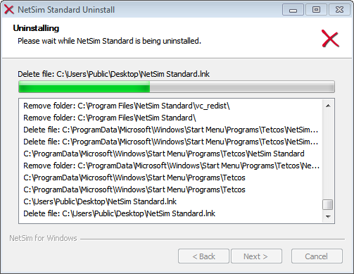

After the uninstallation of core files, uninstallation of the supporting software begins.

To continue uninstalling, click on **Next** on both consecutive windows.

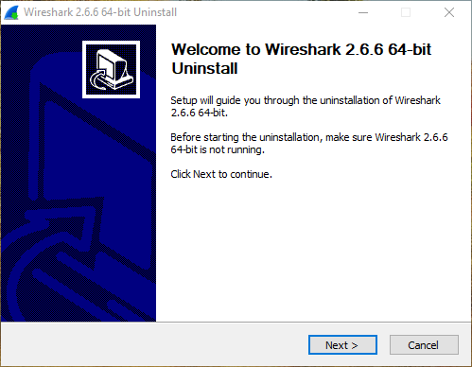

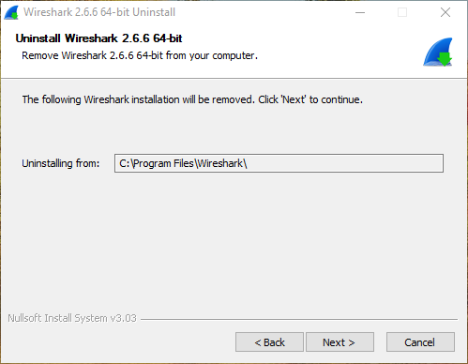

Click on **Uninstall** button to un-install the software.

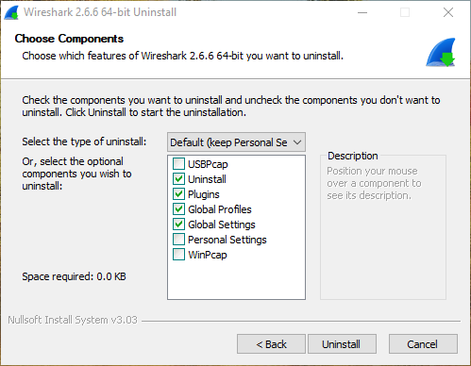

Click on **Finish**.

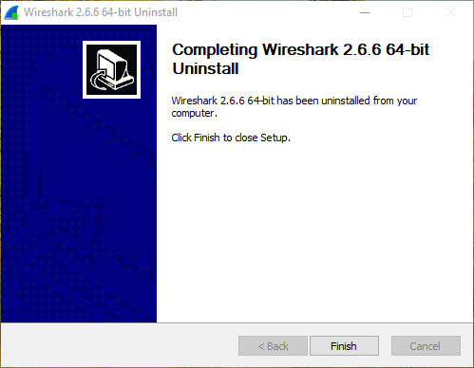

Click on **Finish** button to complete the un-installation process. Thus the NetSim is uninstalled.



***Note: For NetSim Academic, Adobe Flash Player, winPcap and Wireshark will be uninstalled.***

# Troubleshooting

## Adding exception for NetSim in Kaspersky Antivirus

If any exe's in the NetSim gets deleted due to Kaspersky antivirus here are some steps to add NetSim exe's as an exception in Kaspersky Application without disabling the Antivirus protection.

**Step 1:** Open Kaspersky Window, Click on Settings as shown in the figure:

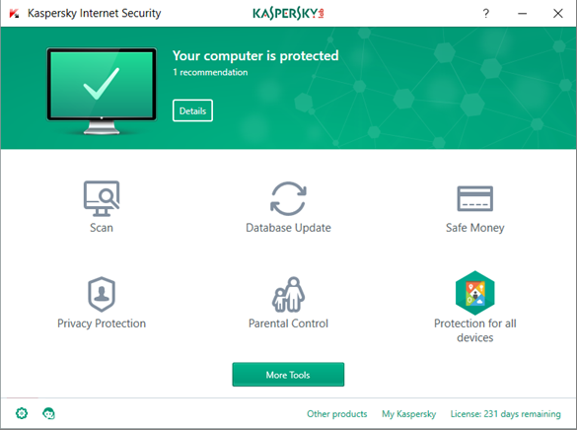

**Step 2**: Click on Additional

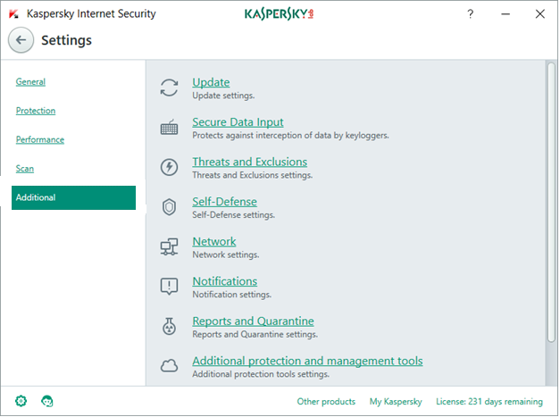

**Step 3:**Click on Threats and Exclusions

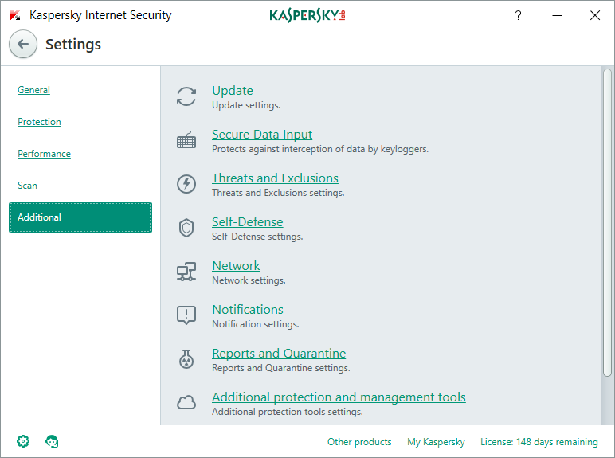

**Step 4**: Click on Manage Exclusion

**Step 5**: Click on Add

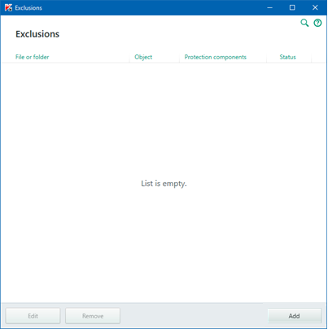

**Step 6:** In the **"File or Folder"** text box browse to **<NetSim_Install_Directory>/bin** or copy and paste the bin path of your NetSim Directory which will be like "**C:\Program Files\NetSim Standard\bin**"

To get the path of NetSim bin path easily just right click on NetSim Shortcut on Desktop click on "Open File Location", copy paste the path to this "File or Folder" text field.

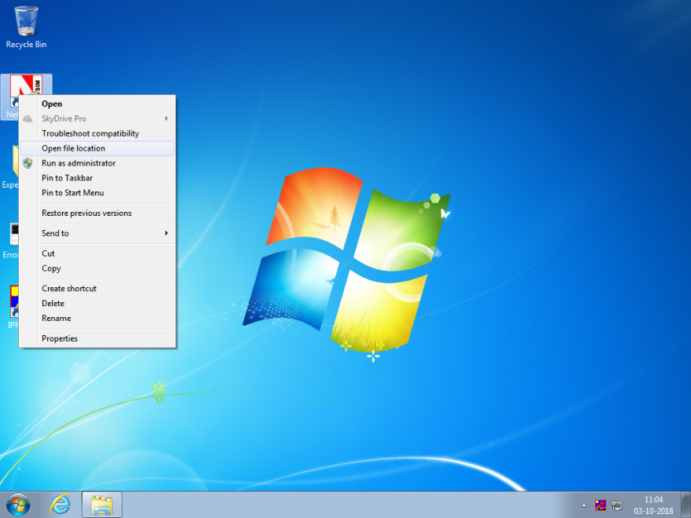

[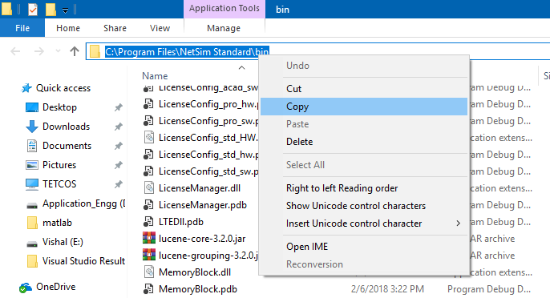](https://s3.amazonaws.com/cdn.freshdesk.com/data/helpdesk/attachments/production/14033139275/original/7sLyIXEUfgZGq2IVZHCMX9547t_9o_WQ9A?1531230573)

[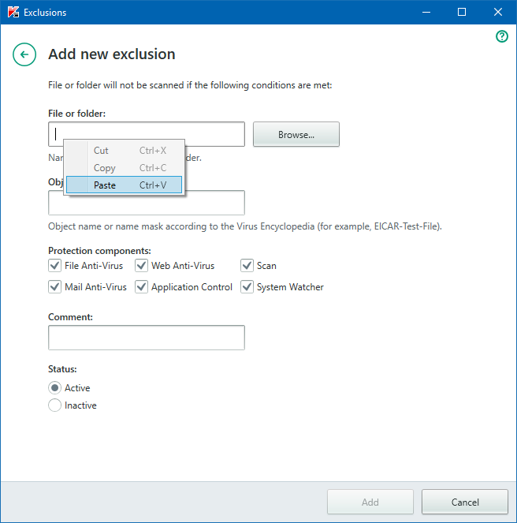](https://s3.amazonaws.com/cdn.freshdesk.com/data/helpdesk/attachments/production/14033139347/original/kBcN4onq4KuIpH4VHsWhhhjiIly9B0HI_A?1531230665)

**Step 7**: Click on **Add**, press **Continue** if any prompt displays

**Step 8**: Now click on "**Specify Trusted Application"** next to Manage Exclusion

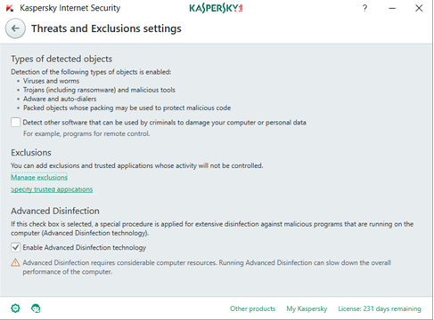

**Step 9:** Click on**Add**button

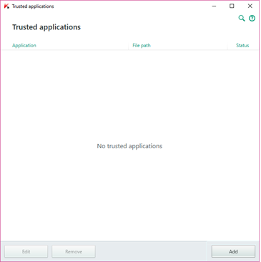

**Step 10**: Click on Browse

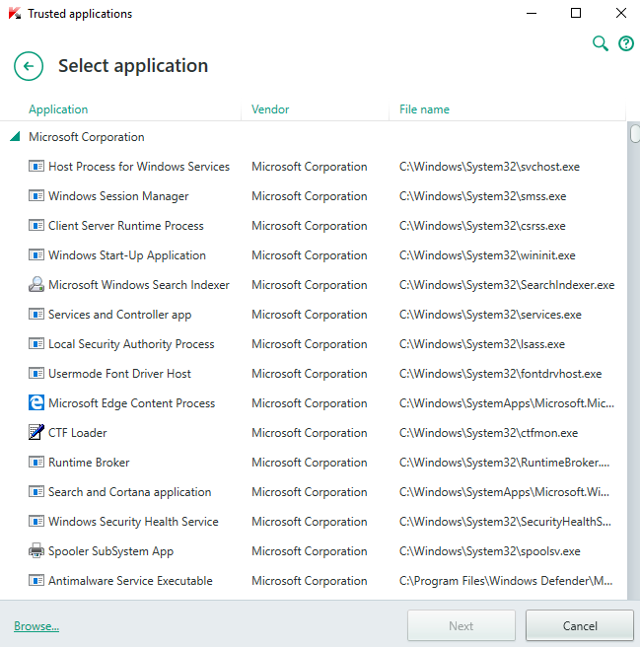

**Step 11:** Go to NetSim bin folder and select NetSimSimulation.exe

**[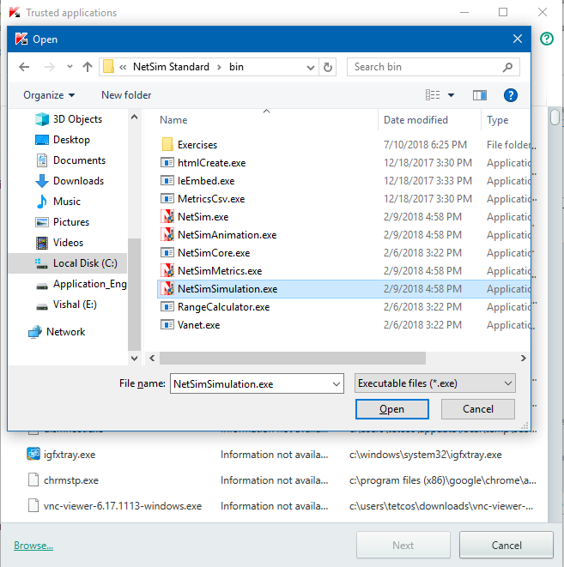](https://s3.amazonaws.com/cdn.freshdesk.com/data/helpdesk/attachments/production/14033139762/original/zLohQK6YUROsY_CYUqxcVQvGT_q0jnrvwQ?1531231040)**

**Step 12:**Click on Open

**Step 13**: Check several checkboxes as shown in the figure and then click on Add. Close Kaspersky.

[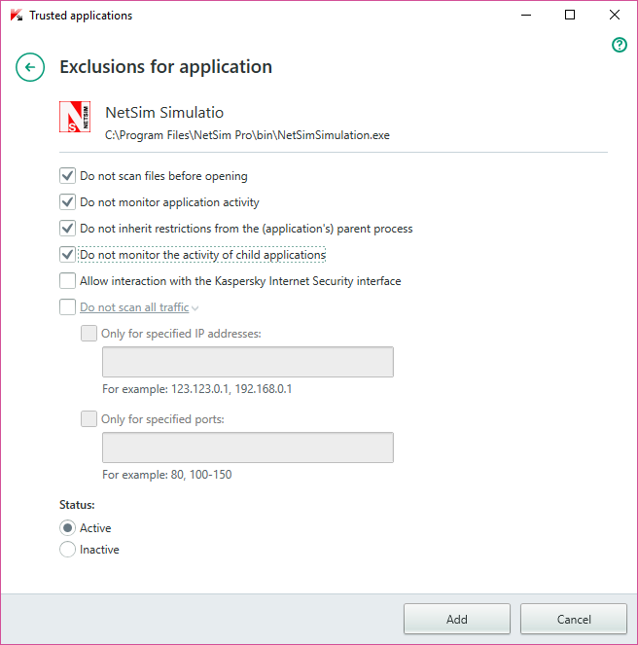](https://s3.amazonaws.com/cdn.freshdesk.com/data/helpdesk/attachments/production/14033142982/original/-er92DvtjUanLcEpd0dZd6bUzQ0GTBzhCg?1531234134)

**Note**: If Kaspersky has previously removed the**NetSimSimulation.exe,**then it might not be possible for you to "**Specify Trusted Applications**", as explained in Step 8 onwards. To restore NetSimSimulation.exe, you could reinstall NetSim either silently to save time or manually as per your convenience.

## Adding exception for NetSim in Trend Micro Antivirus?

If any exe's in the NetSim gets deleted due to Trend Micro antivirus here are some steps to add NetSim exe's as an exception in Trend Micro Application without disabling the Antivirus protection

**Step 1:** Open **Trend Micro Antivirus**, Click on **Settings** as shown in the figure.

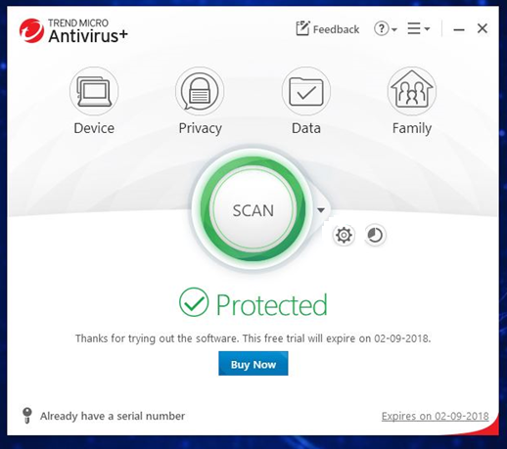

**Step 2:**Click on Exception Lists

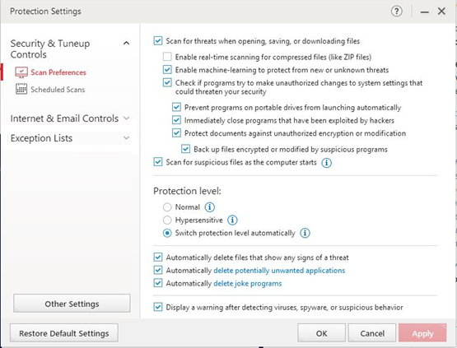

Step 3: Click on **Programs/Folders**

[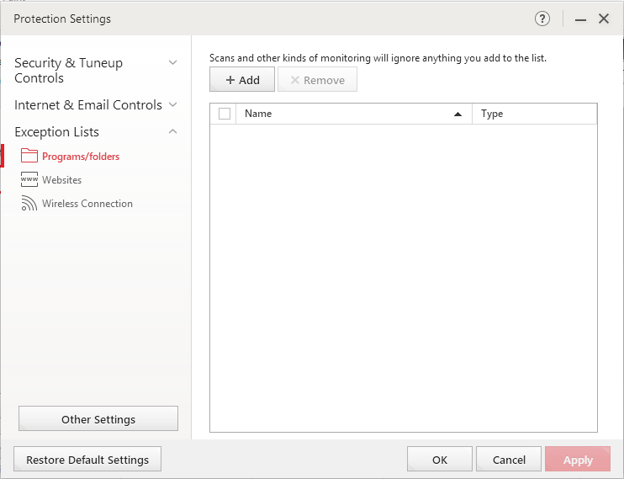](https://s3.amazonaws.com/cdn.freshdesk.com/data/helpdesk/attachments/production/14034168886/original/0_mP0o-iR0sMFMs6vslb53K8IRru3vQdpw?1533233758)

**Step 4**: Click on +Add

**Step 5**: Click on Browse

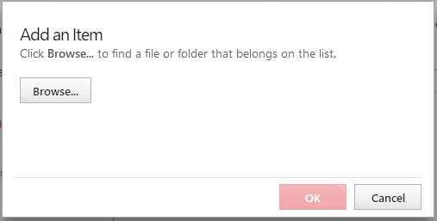

**Step 6:** Add bin folder from NetSim Directory which looks like **"C:\Program Files\NetSim Standard\bin"**

**[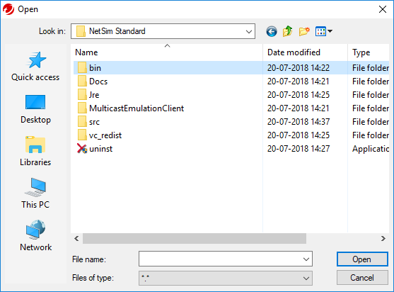](https://s3.amazonaws.com/cdn.freshdesk.com/data/helpdesk/attachments/production/14034169162/original/-w3VaW84xja9aqwDstCz5drvsWJxqfyA2Q?1533234161)**

**Step 7**: Click on Open

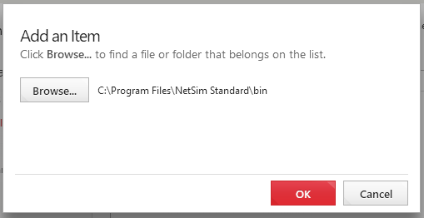

**Step 8**: Click on **OK**

**Step 9**: Click**Apply**

Note: Trend Micro Antivirus may have has previously deleted the NetSim executables. We recommend you uninstall and re-install NetSim.